For Research Coordinators / Associates
Associate an inpatient to a research study:
- Login with your user ID and password.
  - Department is always CORE-ctr for research excel (for everyone)
  - Home screen should show the research dashboard
- Select Patient Lists from the main toolbar on top.
- Select System Lists from the navigator toolbar on the left.
- Select the unit to which the patient was admitted.
- Double-click the patient's name to open the encounter.
  - Alternatively, you may select Pt Research Studies from the main toolbar and enter the patient’s name or MRN directly.
- Select ‘Research Studies’ from the navigator toolbar on the left.
- Click Add to select a research study.
- Double Click the appropriate research study.
- Select the ‘Link to current visit’ check box ONLY if this visit involves Research billing items for Kevin to review.
- Assign the appropriate research coordinator.
- Enter the appropriate study status from the category list (Enrolled, etc.)
- Enter any other optional information for the study or patient. Click Accept.
- Close the activity and click More Activities on the bottom left.
  - Click the FYI Flag > Select New Flag > Select Research Participant.
  - (You may deactivate the flag once the patient has completed or withdrawn from the study.)
- Close the current patient's chart.
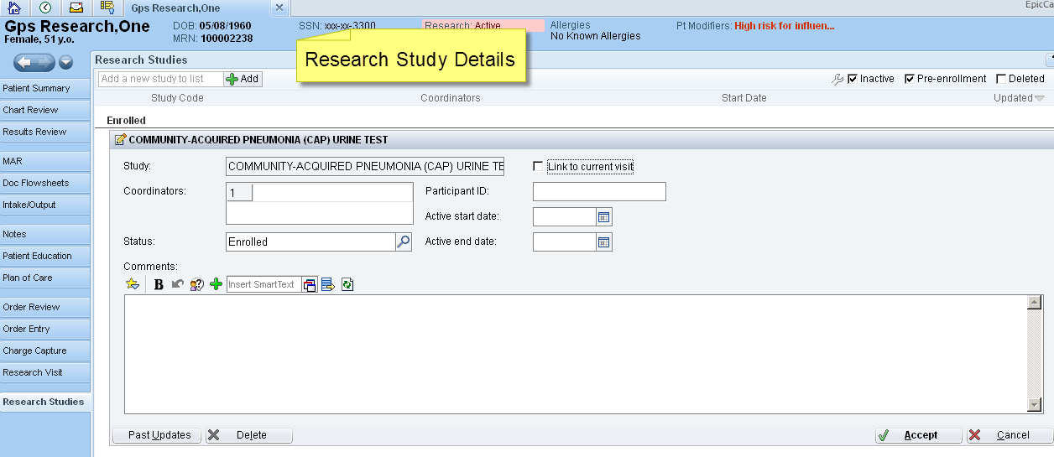
- Please note, you must still submit all Enrollment notification and Billing notification forms to TGH OCR at research@tgh.org.

Viewing an inpatient chart:
- Click on Patient Lists from the top toolbar.
  - Select System Lists from the left navigator toolbar > Select the unit > Select the patient.
- Click Chart Review to review any pertinent data on the patient.
  - Chart Review is like Chartview. It lists past encounters, labs, etc.
  - Scanned documents are under the ‘Media’ tab (ICF, Data sheet, etc.)
- Place orders if necessary.
- Document Progress Note if necessary.
Placing orders in Epic:
- Select your patient.
- Click on Research Visit from the left navigator bar.
- Select Research Orders and enter your order.
  - You can use the Preference List of common orders or the Facility List of ALL TGH orders.
    - Unclick ‘medications’ to view only the list of labs/procedures.
  - You can also select Order Set and find your research order set in the list.
  - Once the order is entered, clicking the blue hyperlink of the order will bring up the order details and you can modify the frequency, dates, etc. as required of the protocol.
- Research RNs will click Sign Orders and select Verbal with readback.
  - Select the provider name.
- Non-nursing research coordinators will click Pend Orders and select Physician will release.
  - The orders are not active until a physician logs in to sign the orders.
  - Any physician, mid-level, or resident will see ‘Pending orders’ on the bottom left and will be able to sign and release the orders.
Outpatient CORE clinic visit:
- Login with your user ID and password.
  - Department is always CORE-ctr for research excel (for everyone)
  - Home screen should show the research dashboard
- Click on the schedule (clock) icon to open the schedule.
  - Click on the folder named: CORE-ctr for research excel
- Double-click the patient on the schedule to access the patient’s chart.
  - The research navigator should open.
  - Place Orders or document Progress Notes as above.
Scanning into Epic:
- When scanning into Epic, each document must have the correct document cover sheet.
  - We have a cover sheet for each research form (ICF, Device data sheet, Research Information sheet).
  - You may also fill out the Consent Checklist, if you prefer, and scan it with the patient’s ICF.
- You must also put a patient label on each cover sheet (available near the patient’s mini chart on the unit).
- Follow the instructions on the Ricoh scanner to scan the documents (you will need to swipe your badge for access).
- Once scanned, stamp the documents as “scanned” (stamp should be available on the unit) and place the Data sheet and Research information sheet into the patient’s mini chart on the unit.
  - The copy of the ICF must be placed into the red TGH HIM dept. bag to go to HIM for verification.
  - All scanned documents will appear in the Media tab of the patient’s chart, under ‘Research Authorization’ (most recent documents on top).
Remote access to Epic Hyperspace:
- From any computer with internet access outside the TGH network, go to https://connect.tgh.org
- Log into the Citrix portal with your TGH network credentials (alpha-numeric badge ID username and password).
  - If it’s your first time logging into the network, your user ID is your alpha-numeric badge number (example: f12456). It is your 6-digit badge number with the first number converted to a letter (conversion: 0=a, 1=b, 2=c, 3=d, 4=e, 5=f, etc.)
  - Your default password is the first initial of your first name in upper case, the first initial of your last name in lower case, and the last 4 digits of your badge number (John Doe example = Jd2456).
  - If your computer has never run Citrix before, you will be prompted to download the Citrix client. Just follow the prompted instructions (may take several minutes to install).
- Once logged into the TGH Citrix portal, the Epic Hyperspace icon will be available. Click the icon to start your session.
- Once the session starts, log into Hyperspace with the same TGH network credentials that you used to log into the Citrix portal.
- If you need further assistance, please call the TGH technical support center at 813-844-7490.
Monitor access to Epic:
- Please contact the TGH Office of Clinical Research at 813-844-7989 or research@tgh.org if your monitor needs access to Epic or Chartview.

